Name: Syed Shayan Arshad
Roll No: 2023-CS-625
Project Report
------------------------------------------------------------------------------------------------
Urdu Alphabet Classification using Deep Learning Models
1. Project Overview
This project focuses on Urdu alphabet classification using Deep Learning techniques. Two models, Deep Neural Network (DNN) and Convolutional Neural Network (CNN), were implemented and compared to recognize Urdu character images accurately from preprocessed data.
2. Dataset Collection and Pre-processing
2.1 Dataset Description
The dataset for this project was self-created by collecting handwritten images of Urdu alphabets and saving them as JPEG files. It contained 38 classes representing standard Urdu characters, with one image for each class.
2.2 pre-processing pipeline
Each raw image was processed through the following sequential steps:
Step | Operation | Detail
1 | Read Image | OpenCV imread(): loaded as BGR colour
2 | Resize | Resized to 64 × 64 pixels using cv2.resize()
3 | Grayscale Convert | BGR to Grayscale using cv2.cvtColor(COLOR_BGR2GRAY)
4 | Normalise | Pixel values divided by 255.0 having range [0, 1]
5 | Reshape for CNN | Shape expanded to (64, 64, 1): single channel
2.3 Data Augmentation
With only one image per class, a model trained on the raw data would immediately overfit. To artificially expand the dataset, Keras' ImageDataGenerator is used.
Augmentation Parameter | Value / Range
Rotation range | ±6 degrees
Width shift range | ±2 % of image width
Shear range | 0.1 radians
For each of the 38 original images, 15 augmented variants were generated, bringing the total augmented dataset to 38 × 15 = 570 images.
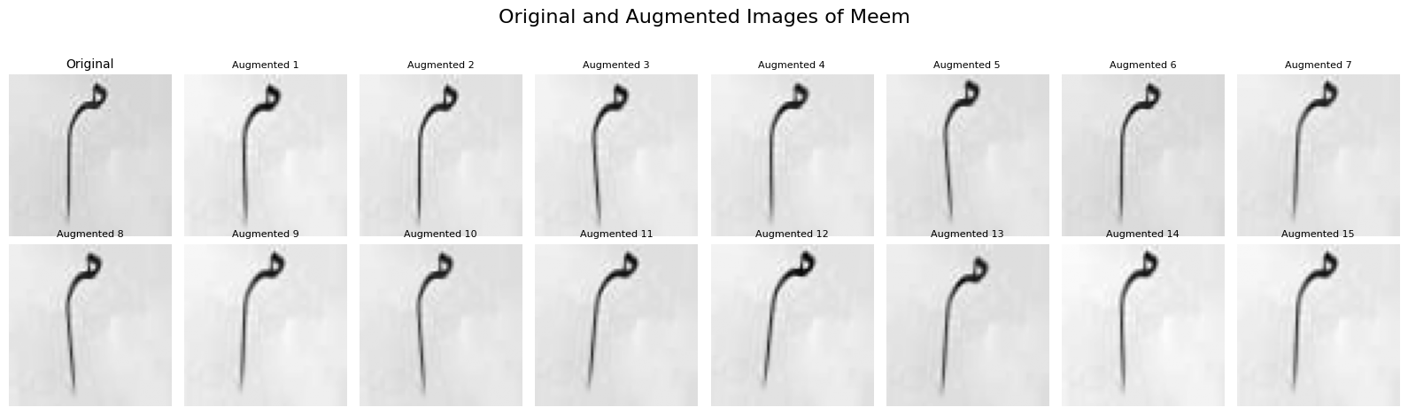
3. Model Architectures
3.1 Deep Neural Network
The DNN serves as a fully-connected baseline. Each 64×64 image is flattened into a 4,096-dimensional vector before being fed into the network.
Layer | Units / Config | Activation
Input (Flatten) | 4096 (64 × 64) | —
Dense | 256 neurons + BatchNorm + Dropout(0.3) | ReLU
Dense | 128 neurons + BatchNorm | ReLU
Output Dense | 38 neurons (one per class) | Softmax
The DNN model was compiled using the Adam optimizer and categorical cross-entropy loss. Batch normalization and dropout were used to improve training stability and reduce overfitting, while early stopping prevented over-training.
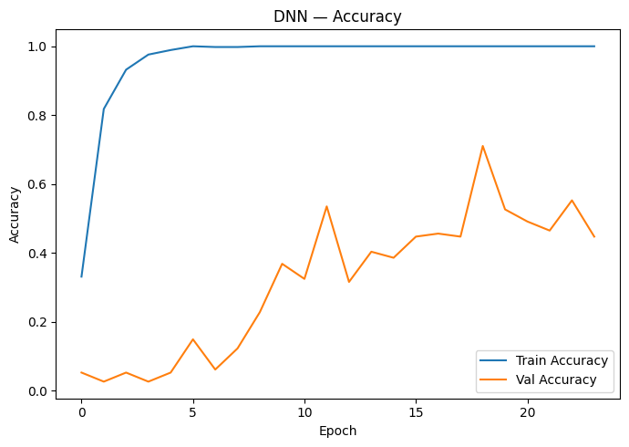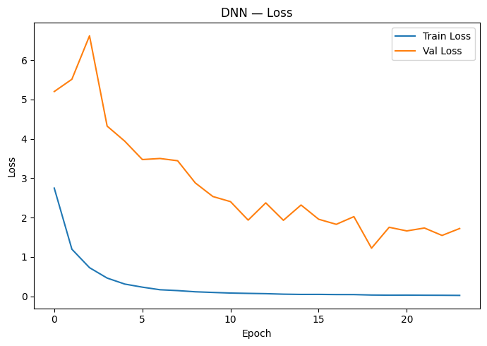
3.2 Convolutional Neural Network (CNN)
The CNN preserved the 2D structure of 64×64 images and learned important features through convolutional layers.
Layer | Configuration | Output Shape
Conv2D | 32 filters, 3×3 kernel, ReLU | (62, 62, 32)
MaxPooling2D | Pool size 2×2 | (31, 31, 32)
Conv2D | 64 filters, 3×3 kernel, ReLU | (29, 29, 64)
MaxPooling2D | Pool size 2×2 | (14, 14, 64)
Flatten | — | (12544,)
Dense | 128 neurons | (128,)
Dropout | Rate = 0.5 | (128,)
Output Dense | 35 neurons | (38,) (Softmax)
The CNN was was compiled using the Adam optimizer and categorical cross-entropy loss. Early stopping with a patience of 5 was applied, and the model was trained for up to 50 epochs with a batch size of 32.
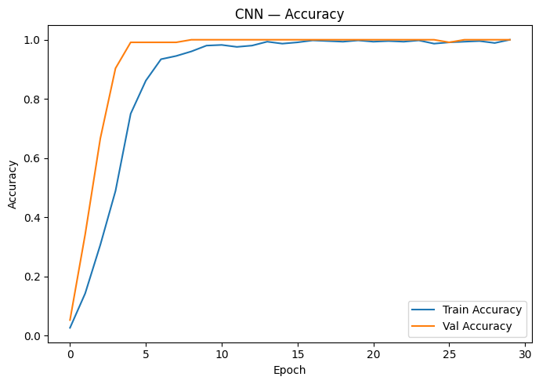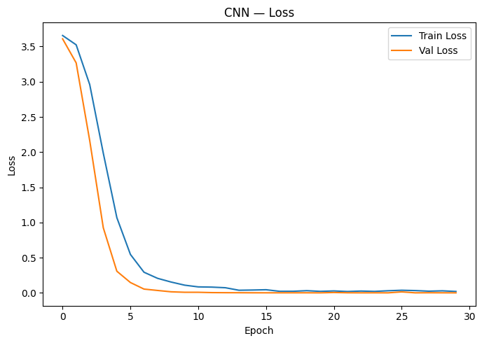
3.3 Feature Map
Feature map visualizations were generated to analyse the internal working of the CNN using a sample Urdu alphabet image.
The first generated feature map corresponds to the initial convolution layer, where the network detects basic visual structures such as edges, strokes, curves, and character boundaries. Different channels highlight various low-level features of the Urdu character image.
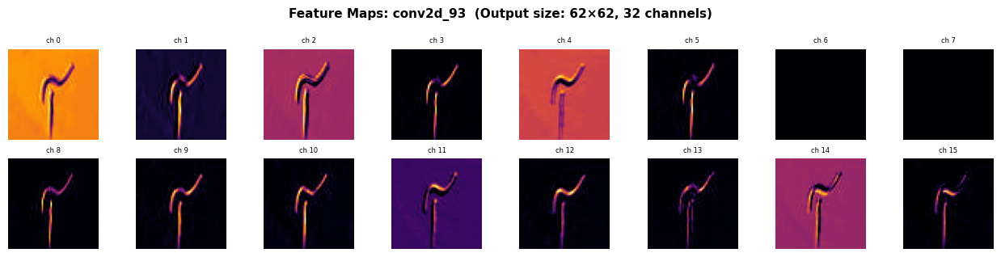
The second feature map represents deeper CNN activations, where low-level patterns are combined to identify more complex Urdu character features for accurate classification.
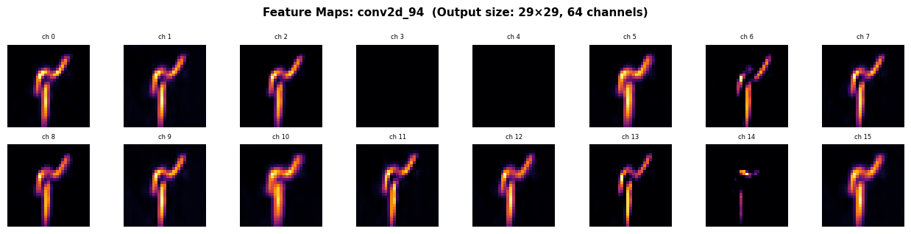

Feature map visualizations show how the model converts raw pixel data into meaningful features for accurate character classification.
3.4 Training Procedure
The augmented dataset of 570 samples was split into 80% training and 20% testing sets using stratified sampling. Labels were one-hot encoded, and EarlyStopping with a patience of 5 was applied during training to restore the best model weights automatically.
Parameter | DNN | CNN
Input Shape | 4096 (flat) | (64, 64, 1)
Optimiser | Adam (lr=0.0005) | Adam (default lr=0.001)
Loss | Categorical Cross-Entropy | Categorical Cross-Entropy
Batch Size | 32 | 32
Max Epochs | 50 | 50
Early Stopping | Patience = 5 | Patience = 5
Train / Test Split | 80% / 20% | 80% / 20%
3.5 Results and Evaluation
After training, both the Deep Neural Network (DNN) and Convolutional Neural Network (CNN) models were evaluated on unseen test data using metrics such as accuracy, loss, and confusion matrices.
The CNN model achieved better performance in recognizing Urdu alphabets due to its ability to extract visual features effectively, while the DNN model was less efficient because it relied on flattened pixel data.
Model | Training Accuracy | Validation Accuracy | Test Accuracy
DNN | 99.2 | 44.7 | 71.05
CNN | 98.7 | 99.1 | 99.5
3.6 Conclusion
This project used deep learning models for Urdu handwritten alphabet recognition. A dataset of 38 Urdu characters pre-processed into 64×64 grayscale images and augmented to create 570 training samples. Two models, DNN and CNN, were trained and evaluated, with the CNN achieving better accuracy due to its effective feature extraction capability.

